The UK framework for aquatic monitoring

Introduction
Evidence, in the form of monitoring, modelling and analysis, enables us to make informed decisions about the environment.
The UK environment agencies monitor and model the water environment to identify changes over time and to understand how these changes affect the services the water environment provides. The information gathered is key to ensuring the decisions we take to protect and improve the environment result in real changes.
The primary focus of our evidence strategy must be to ensure we have the information required to make decisions to improve and protect the water environment, facilitate sustainable development and contribute to the health and well-being of the people.
We need to radically change the focus of our evidence gathering to encompass these wider social aspects, and do more to benefit from advances in technology and innovation.
This paper sets-out a high-level UK approach to how we intend to change our evidence-gathering approaches, and identifies some key areas where the agencies can work together more closely.

Principles for our evidence-gathering
These broad principles came from a series of discussions between agencies, culminating in a workshop organised by UKEoF. They are draft, and open to revision.

Figure.1 Decision matrix for evidence-gathering programmes
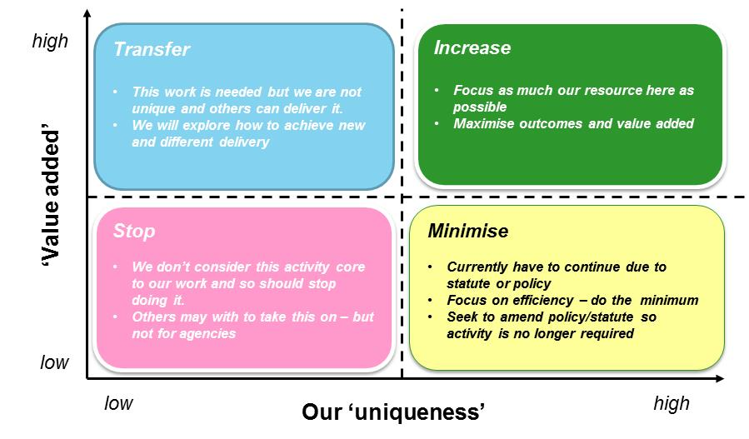
Each agency is reviewing their evidence needs, and identifying areas where more evidence is needed, and those where reductions can be made. Assigning a “value” (i.e. how useful the evidence is in achieving our purpose) and an assessment of how “unique” our agency is in providing the information gives four options for action, from stopping the work to increasing it.
The importance of partnership working will continue to increase, and is appropriate in all aspects of our evidence gathering.

All monitoring should be tied to evidence needs
We need to ensure that all monitoring and modelling activities link to our overarching evidence framework and needs. The focus of our evidence-gathering must be risk-based, and target our resources to the greatest risks. Historically, statutory drivers (e.g. freshwater fish directive) have tended to skew our focus, tying resources into fulfilling reporting requirements rather than targeting and resolving environmental harms. Whilst reporting requirements are important, we will not let them be the primary driver of our monitoring effort.
The environment is dynamic, and any monitoring programme must also be flexible and adaptable to our changing evidence needs. Periodic review of the monitoring network is necessary to ensure this.
We will maintain a long-term network to assess the overall state of the environment and long-term environmental change. This sentinel network will give detect long-term changes, which may not be detected by specific, risk-based monitoring.
The rest of our monitoring activities should follow an ‘investigate, resolve, move on’ approach, to maintain focus on the most pertinent challenges we face.

We will develop our evidence base using the most cost-effective means possible.
Operators and land managers spend significant resources improving the environment to meet various legislative and policy drivers. Equally, the costs of damaging the environment can be immense (both the costs of remediation and the opportunity-lost costs), so our monitoring and modelling must deliver robust evidence.
We should gather our evidence on the environment in the most effective manner we can, incorporating innovative techniques and approaches. Our effort should be proportionate to the questions we are trying to answer, and the risks associated with making the wrong decision. Our evidence will include estimates of uncertainty.

Figure.2 Hierarchy of evidence-gathering

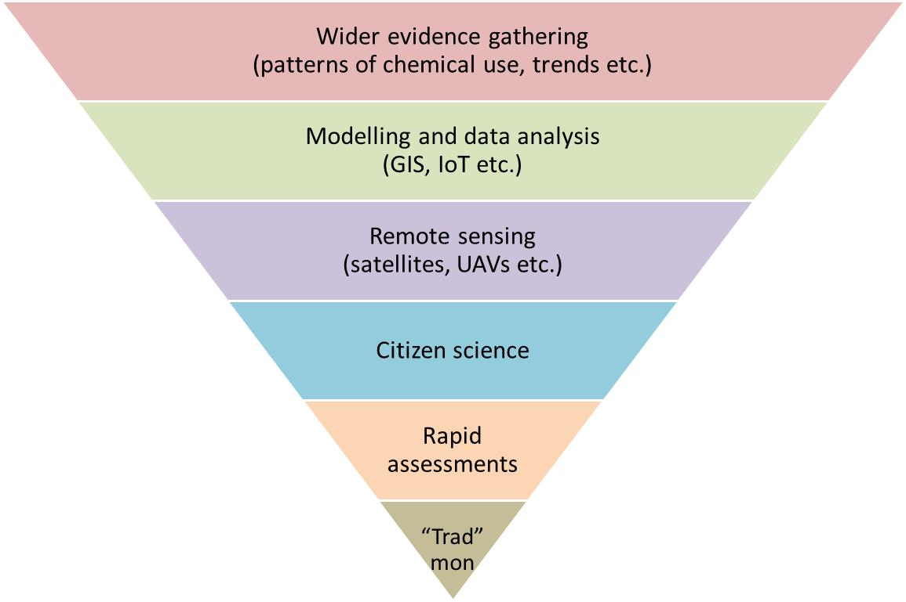
We will use the above conceptual hierarchy when selecting the most appropriate means to gather evidence. Techniques at the top of the hierarchy generally cost less per unit of information, those towards the bottom tend to be more accurate and have lower levels of uncertainty. “Traditional” monitoring includes methods like the collection of water or macro-invertebrate samples for analysis back in the laboratory.
Models and remote sensing will increasingly be used to explain and predict environmental change. We will incorporate information from third parties, and actively promote the collection of evidence from the public.
We recognise that caution must be taken when using modelled results in decision-making as they are approximations for the systems they represent. Modelling must be supported by an underlying monitoring network to ensure the predictions are as accurate as necessary for the decision being made.

We will work with partners to set monitoring priorities, share costs and eliminate duplication
Working within our relevant administrations, and across our countries, we will work with partners to identify gaps in evidence and areas where better co-ordination would deliver significant improvements in our understanding of the water environment.
We will maximise the use of data collected by others; we will not undertake monitoring where we can get appropriate data from other sources.

The focus of our effort will be re-prioritised
Evidence-gathering can be ascribed to three drivers:
- Understand long-term trends and identify future challenges
- Understand and report on the state of the environment
- Manage the environment and make decisions:
  - To assess the effectiveness of our measures and assess change
  - To secure improvements where the state of the environment is unsatisfactory
  - To protect the environment from deterioration and assess capacity for development
  - To predict events, and provide evidence on how to respond, mitigate and remediate
Although there is always a primary driver, individual evidence-gathering programmes can provide information for more than one purpose.
Substantial effort has been expended, particularly over the last six years, on understanding the state of the environment. This was a major driver historically, and was given renewed impetus under the WFD. We have the best understanding yet of the state of the aquatic environment in the UK, and we have reported this into the second River Basin Management Plan.
We will continue to be the authoritative voices on the state of the water environment.
Analysis of the state of the environment in the RBMP has highlighted the challenges we face; each administration has to make significant improvements to the aquatic environment over the next six years (and beyond).
We need more targeted and detailed information to help us identify the most appropriate management and regulatory actions to improve the environment; our monitoring must be re-aligned to provide the evidence needed to make these decisions.
Alongside this, we have to understand any long-term changes in the environment and identify new challenges which may be emerging.
We will reduce the effort we put into “state of the environment” monitoring and increase the evidence we provide to make decisions on managing the environment. Our “long-term” change networks will continue at an appropriate scale to provide representative information on the state of the environment and long-term change.

Data and analysis will be used more, and made more accessible
We publish a wide range of data to help increase awareness and understanding of the environment.
Despite this, we do not make our data work as hard as it could. We will interrogate our evidence to get more from it, and continue to improve how we report our evidence to internal and external customers. We will do more to share information with partners and add value to our evidence by combining it with information from others.
We will work to make public all the evidence we collect (subject to security, legal exemptions and confidentiality concerns), and aim to provide tools to enable the public to interrogate and make use of the data collected. We will promote the use and availability of Open Data.

Future review
We will continually improve our evidence-gathering, by testing for redundancy and overlaps with others, examining our evidence needs and capabilities and embracing innovative approaches.

Authors:

Nathan Critchlow-Watton (SEPA)
Jennifer Taylor (EA)
Alun Attwood (NRW)
Wendy McKinley (NIEA)

14th of June, 2016

